**E.ARUN KUMAR**

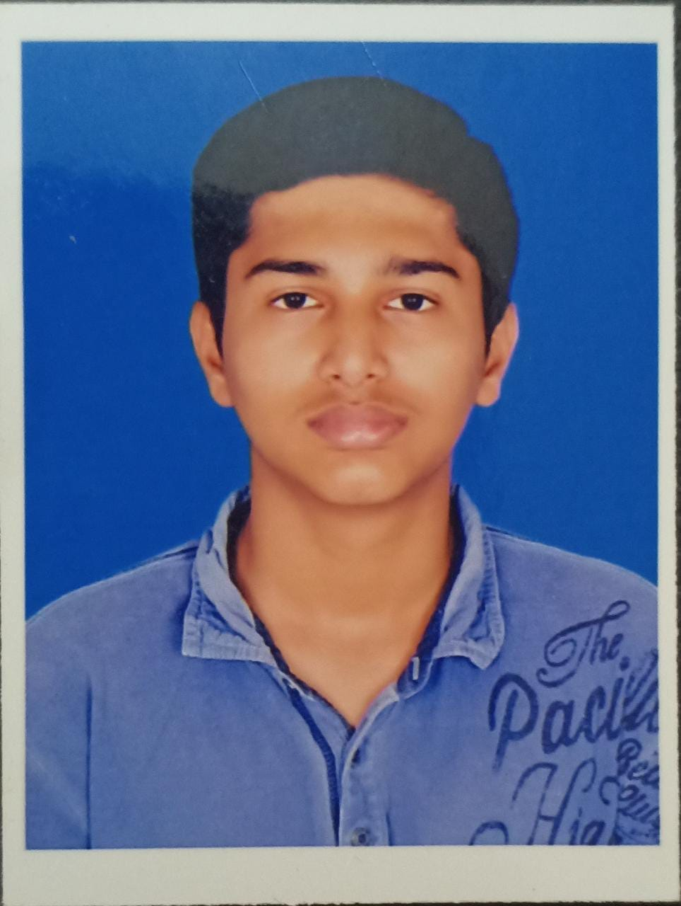

jesaru132001@gmail.com

7708187739

CARRER OBJECTIVE

To seek a responsible position with progressive reputed organization in order to utilize my skills and knowledge to contribute for the enhancement and success of the organization as well as growth of my carrier to optimum level.

ACADEMIC CREDENTIALS:

|  |  |  |  |  |  |
| --- | --- | --- | --- | --- | --- |
| EXAMINATION | QUALIFICATION | SCHOOLING/  COLLEGING | BOARD/  UNIVERSITY | YEAR OF PASSING | % |
| B.E | ELECTRONICS  AND  COMMUNICATION  ENGINEERING | SETHU INSTITUTE OF TECHNOLOGY  (AUTONOMUS) | ANNA UNIVERSITY | 2023 | 8.8%  (CGPA) |
| HSE | Computer science and Maths stream | Mahatma Montessori matriculation HR.SEC school | STATE  BOARD | 2019 | 82% |
| SSLC | SSLC | 2017 | 96.4% |

# AREA OF INTEREST:

* SENSORS OF IOT

## SKILLS:

* COMMUNICATION
* LEADERSHIP
* INTERACTION
* DECISION MAKING
* INTERACTIVE
* CREATIVE
* BASIC OF C
* BASIC OF PYTHON

### STRENGTH:

* SELF CONFIDENT
* SMART WORKER
* VERY SINCERE
* ADAPTABLE
* DEDICATED TO WORK

PERSONAL DETAILS:

NAME : E.Arun kumar

FATHER’S NAME : B.Elango

MOTHER’S NAME : E.Shanthi

DATE OF BIRTH : 01/03/2001

NATIONALITY : INDIAN

LANGUAGE : TAMIL(MOTHER TONGUE), ENGLISH

[ READ ; WRITE ; SPEAK ]

GENDER : MALE

ADDRESS : 1/323-10,shanmuga nagar,near yadava gents college ,new

natham main road MADURAI – 625014 ,

TAMIL NADU

**DECLARATION :**

**I HEREBY DECLARE THAT THE ABOVE MENTIONED INFORMATION IS TRUE TO MY KNOWLEDGE. I BEAR THE RESPONSIBILITY FOR THE CORRECTNESS FOR THE ABOVE MENTIONED PARTICULARS .**

**PLACE : MADURAI**

**DATE : 17/05/2022**

YOUR’S SINCERELY

**E.ARUN KUMAR**